GitHub – Push File

T Godwin Abilash – 192321012

**Set Up Git**

* Install [Git](https://git-scm.com/downloads) on your system if not already installed.
* Configure Git with your username and email:

git config --global user.name "Your Name"

git config --global user.email "youremail@example.com"

git init

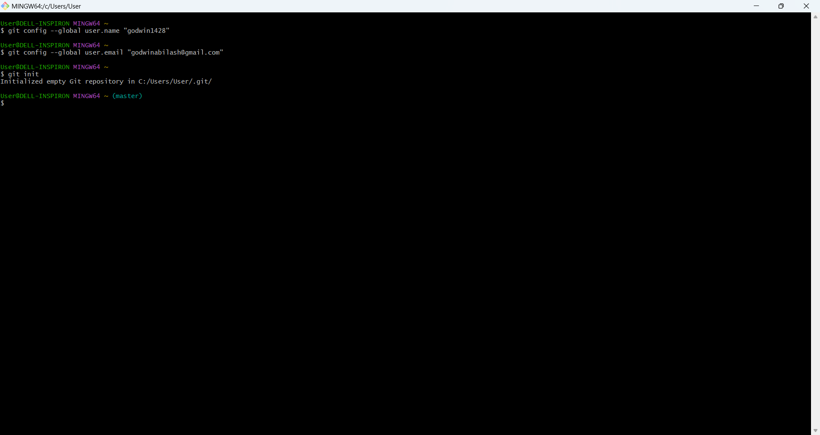

**Use the mkdir command to create a new folder.**

mkdir sepractical

This creates a new folder called my-folder in your current location.

**Navigate into this folder using the cd (change directory) command:**

cd sepractical

**Add or Move Files to the Folder**

* Once you’re inside the folder (software-engineering in this case), you can add files you want to upload:
  + **Create new files** directly:

echo "This is a sample file" > file.txt

This creates a new file called file.txt with the text "This is a sample file".

Verify the Folder Contents

dir

**3. Initialize Git**

* Once you’re in the correct folder, initialize Git to make it a Git repository:

git init

**Verify Git Initialization**

* To confirm that Git is initialized, you can check the status of your repository:

git status

**Create and Switch to the main Branch**

To create a main branch:

git branch -M main

This renames your current branch to main.

**Ensure You Have a Commit**

You must have at least one commit to push. If you haven’t made any commits yet:

1. Stage your files:

git add .

1. Commit your changes:

git commit -m "Initial commit"

**Add the Remote Repository**

If no remote is configured or the origin remote is missing, add it manually:

git remote add origin https://github.com/godwin1428/Software-Engineering.git

**Push to GitHub**

Now push the main branch to your GitHub repository:

git push -u origin main

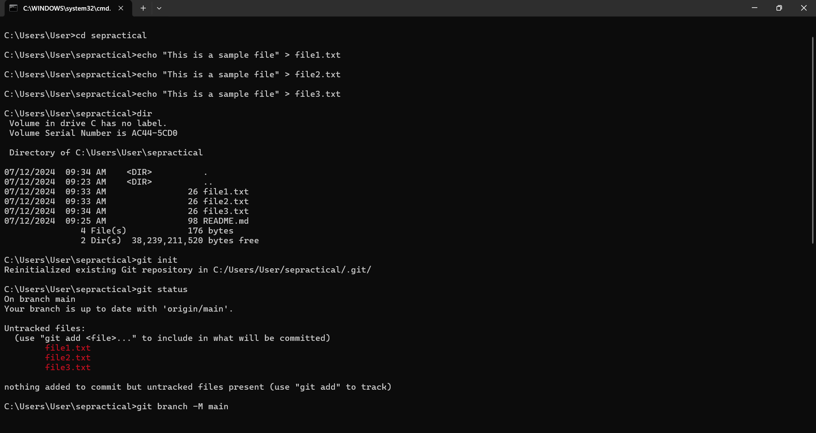

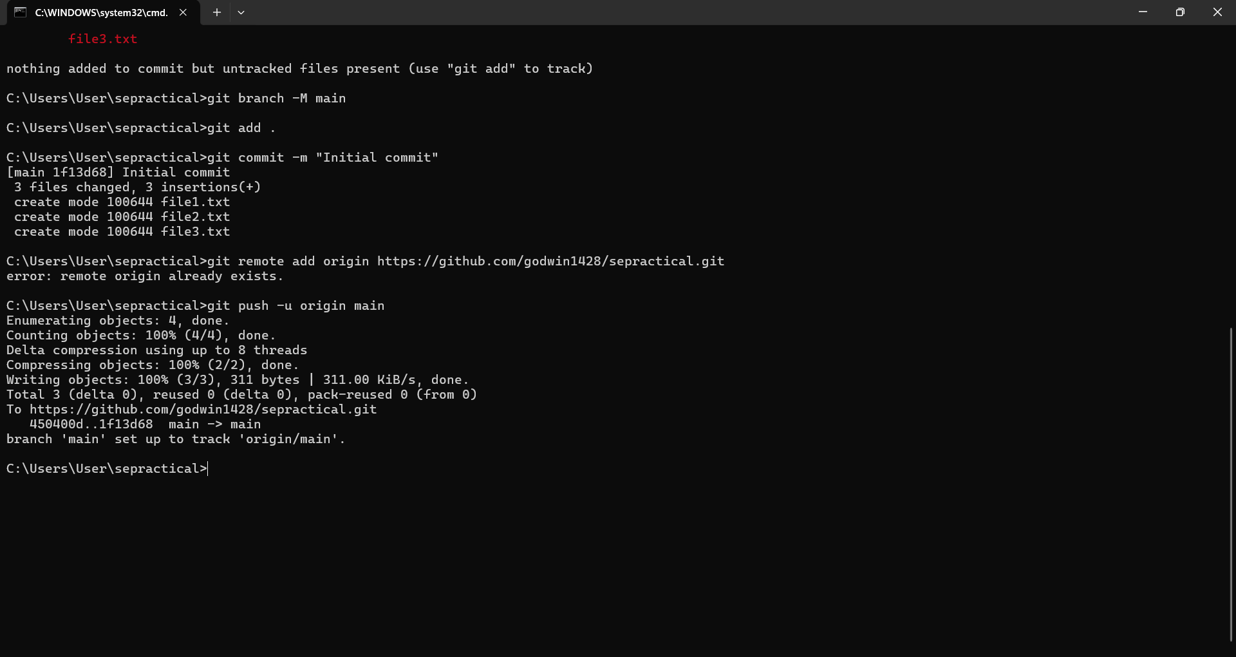

**Verify on GitHub**

1. Log in to GitHub and open your repository.
2. Refresh the page to confirm that your files have been successfully uploaded.

